# User Document – Firmware Installer

## 1. Introduction & Purpose

The **TekMedika Firmware Updater** is a tool designed to simplify the process of installing and managing firmware for Master and Slave Ports. It provides a user-friendly interface to detect connected ports, install firmware, and verify installations. This document serves as a guide for users to set up, install, and use the firmware updater effectively.

## 2. System Requirements

Before using the firmware updater, ensure your system meets the following requirements:

* **Operating System**: Windows 10 or later
* **Hardware**:
  + **RAM**: At least 2 GB
  + **Storage**: At least 100 MB of free disk space
  + USB connectivity for Master and Slave Ports
* **Internet Connection**: Required for downloading firmware files.

## 3. Installation Steps

### Step 1: Download the Installer

1. Download the .exe installer for the TekMedika Firmware Updater from the official source or provided link.

### Step 2: Install the Application

1. Run the downloaded .exe file.
2. Follow the on-screen instructions to complete the installation process.
3. Once installed, the application will be ready to use.

## 4. How to Use the Installer

### Step 1: Launch the Application

1. Open the installed application from the Start Menu or Desktop shortcut.

### Step 2: Login

1. Enter your credentials to log in:
2. Click the **Login** button to proceed.

### Step 3: Select Firmware Version

1. After logging in, select the firmware version you want to install from the dropdown menu.
   * Admin users can select any version.
   * Regular users can only install the latest version.

### Step 4: Install Firmware on Master Port

1. Connect the **Master Port** to your computer via USB.
2. Follow the on-screen instructions to install the firmware on the Master Port.
3. Wait for the process to complete.

### Step 5: Install Firmware on Slave Port

1. Disconnect the Master Port and connect the **Slave Port** to your computer via USB.
2. Follow the on-screen instructions to install the firmware on the Slave Port.
3. Wait for the process to complete.

### Step 6: Verify Installation

1. Reconnect the **Master Port** to your computer.
2. The application will automatically verify the installation by checking the system UID and firmware version.
3. A success message will be displayed if the installation is verified.

## 5. Screenshots

### Main Interface

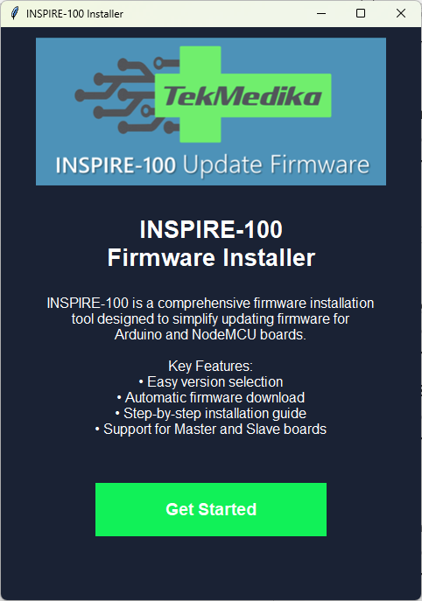

### Login Screen

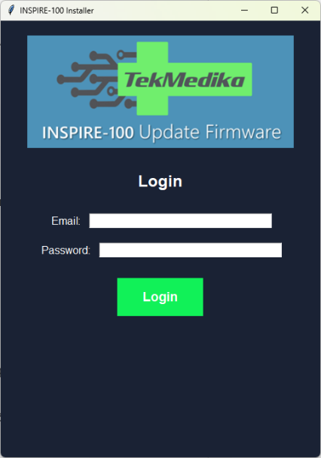

### Firmware Selection

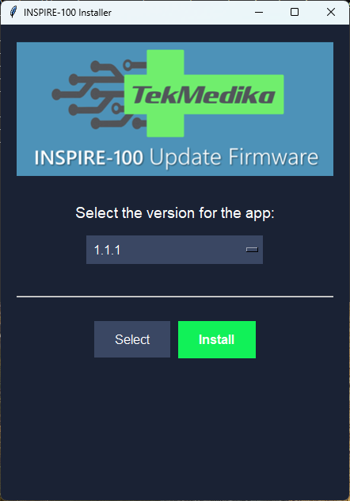 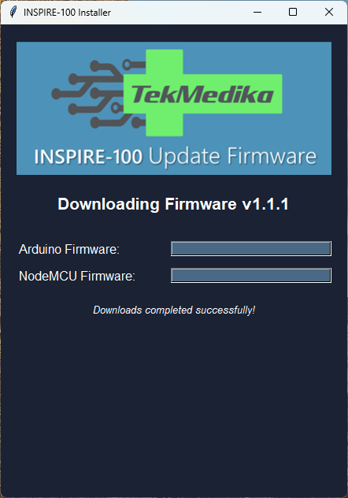 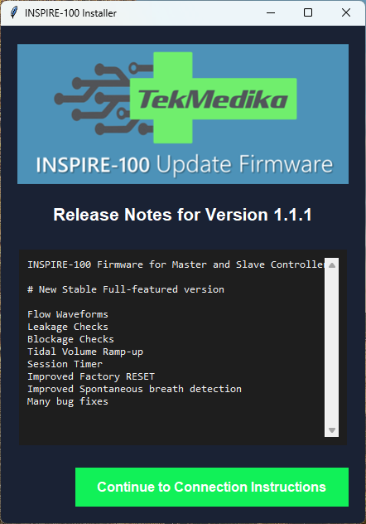

### Installation

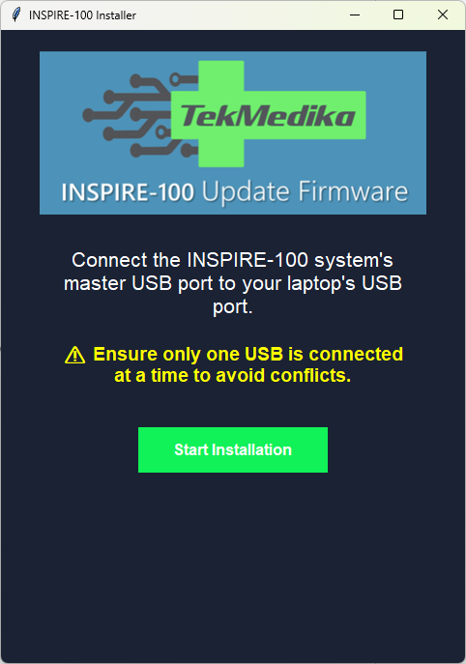 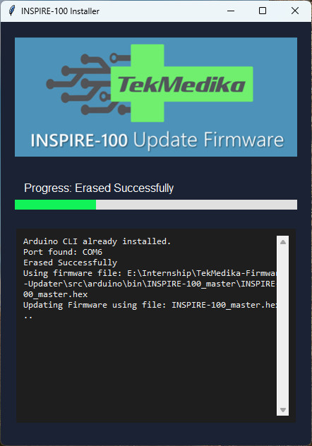

### Completion Screen

